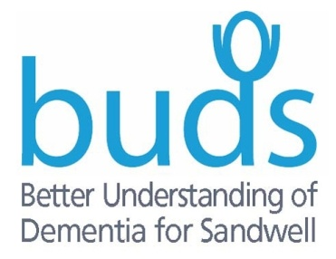
Client Referral Form

Client Details (all fields marked with * must be completed)

*DATE OF REFERRAL
Mr, Mrs, Miss, Ms
*First Name
Preferred Name
*Surname
*Address

*Postcode
*Telephone Number
Mobile Number
*Preferred method of contact
*Date of Birth
*Emergency Contact Name/relationship
*Address

*Postcode
Email Address
*Telephone Number
Mobile Number
How did you hear about BUDS?
For example, Local authority, social worker, GP, website?

Referrer Details (Please only complete those that apply)
*Name of Referrer
Position of Referrer/organisation
*Referrer Telephone Number
Referrer Mobile
Name of Main Family Carer
Family Carer Telephone Number
Family Carer Mobile
Name of GP
GP Telephone Number
Services Required (Please tick all that apply)

BUDS Activity Sessions
BUDS Befriending Service
Client’s likes and dislikes, interests or hobbies, etc.

Client Health

*Diagnosis (e.g. Dementia, Learning Disabilities, Cancer) and Date
*Summary of main difficulties experienced, and any potential risk to self or others
Medication

Any physical health conditions or mobility problems

Diversity Monitoring - (Please tick)

White |  | Catholic
Black Caribbean |  | Christian
Black African |  | Sikh
Asian |  | Hindu
Dual Heritage |  | Muslim
Other (please state) |  | Other

Client Sign......................................................Date...................

Referrer/Carer Sign............................................Date..................

Please return this form to:
BUDS, Hope House George Road Community Church 142 George Road Oldbury West Midlands B68 9LN
Phone: 0121 565 3721 Mob: 07972 601 359 Email: info@buds.co.uk

Sandwell Council contracts with voluntary sector organisations who provide services to carers who live in Sandwell or who look after people who live in Sandwell, to ensure that carers’ needs, and outcomes are effectively met in the most appropriate way. If you approach or use one of these carer's services, they may need to refer you on to another organisation who specialises in the support you need. This will mean that your name and contact details will be passed on. As one of these carer's services, we will always pass on the least information necessary to provide you with a service and will always tell you if we are passing on that information and to which organisation. We will always respect your confidentiality, and you can ask that you are not referred. You may want us as the referring organisation to stay involved with your support and you can tick a box below to consent to that.

I consent to my information being shared with other carer's organisations Yes No

I consent to my referral organisation, BUDS being kept informed of my support
YES NO

